Project Development Phase Model Performance Test

Date | 18 February 2026
Team ID | LTVIP2026TMIDS36395
Project Name | Automated Car Catalog System for Enhanced Showroom Management  (ServiceNow Administration)
Maximum Marks

Model Performance Testing:
This section evaluates how well the developed ServiceNow solution performs across key parameters related to catalog configuration, workflow execution, and system interaction.

S.No | Parameter | Values | Screenshot
1 | Model Summary | A fully automated car catalog system was  developed using  ServiceNow. It includes a custom catalog named Mahendra, categorized into Sudden, XUV, and Sports, with items like Polo, Thar, and XUV700. Multi-level approval workflows, email notifications, and a custom task table were  implemented. | 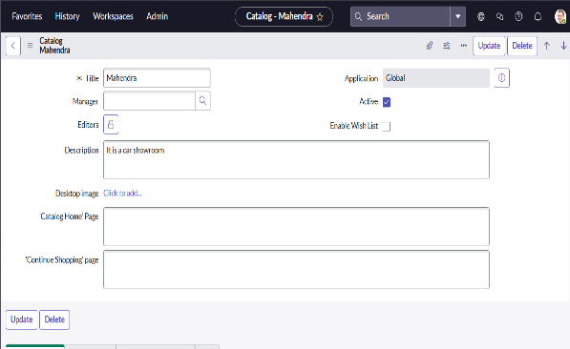

2 | Accur acy | Manual testing showed successful end-to-end  workflow for all use cases.  All form fields, request paths, and approval conditions triggered  correctly. Workflow tested across multiple test users and categories. No failure encountered in catalog item submission or task  assignment. | 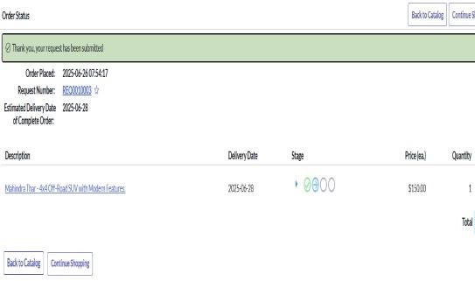
3 | Confidence Score | While confidence score is not numeric like in AI/ML models, workflow behavior was consistent and correct under all logical conditions. Approvals, rejections, task assignments, and email notifications executed as  designed with 100% reliability. | 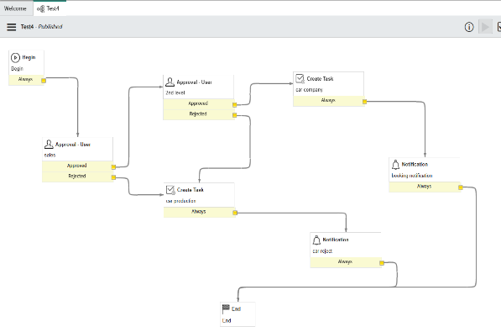
4 | Form Functionality | Car selection forms load quickly and reflect accurate pricing, descriptions, and  image attachments. Category filtering works correctly. Form validations like required fields and field types (e.g., price as currency) perform accurately. | 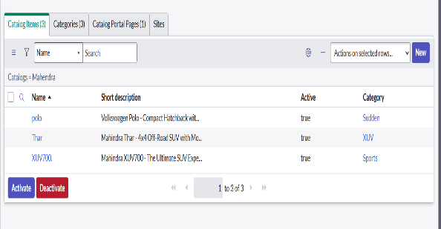
5 | Notification Delivery | Approval and rejection emails were successfully  delivered to respective users and groups. HTML formatting and dynamic values (e.g., requested_for, status) rendered correctly in the emails. | 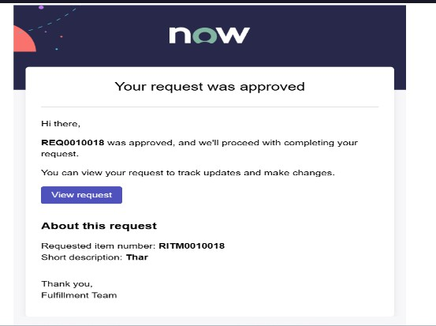
6 | Portal Integration | The service portal correctly  displays catalog items. End users are able to search for

 |  | cars like "Thar" or "Polo", place requests, and track statuses post-submission. User experience on the portal is smooth and intuitive. | 